ASG TASKS
- Create one VPC in N. Virginia region.
- Go to vpc change region to N.virginiacreate vpc nameCIDR -range createvpc
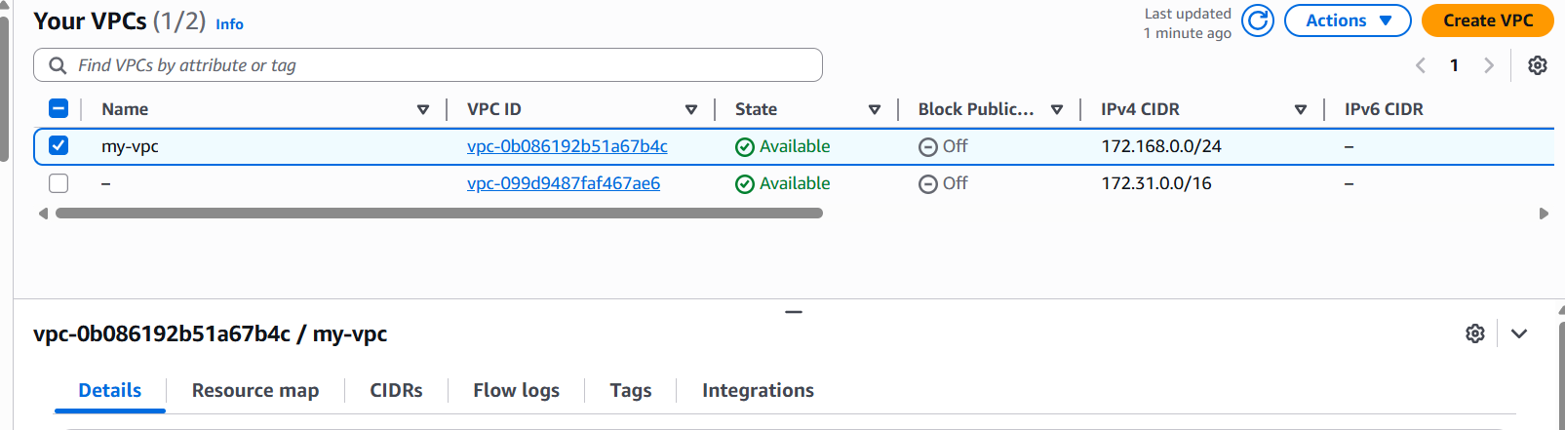

- Create two subnets: one public subnet and one private subnet.
- Go subnetscreate subnet two subnets give name give cidr blockcreate subnet
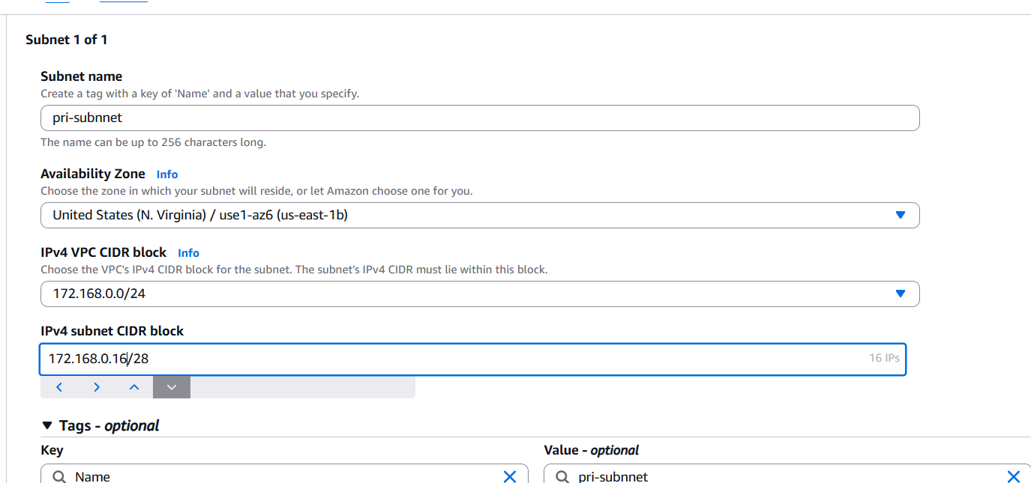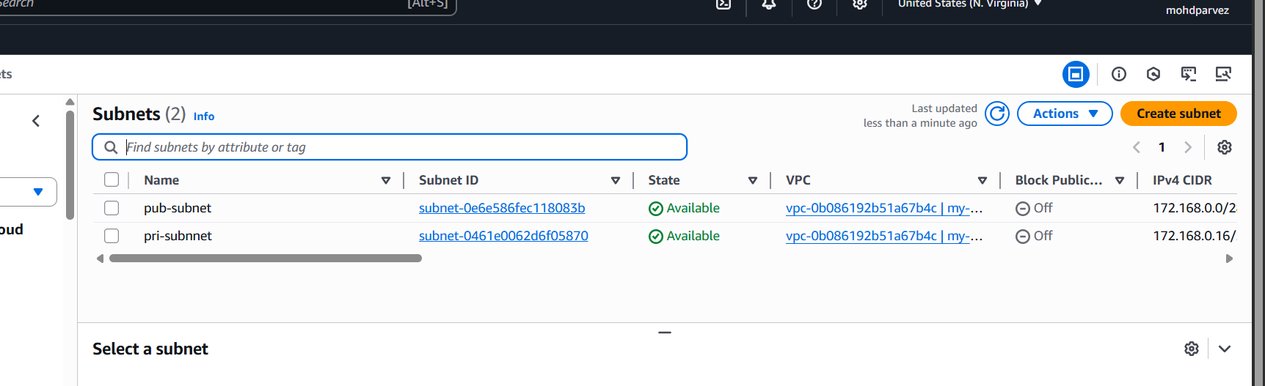
- Attach an IGW to the VPC.
- Got IGWcreate new IGW or select the existingattach to vpc you have created
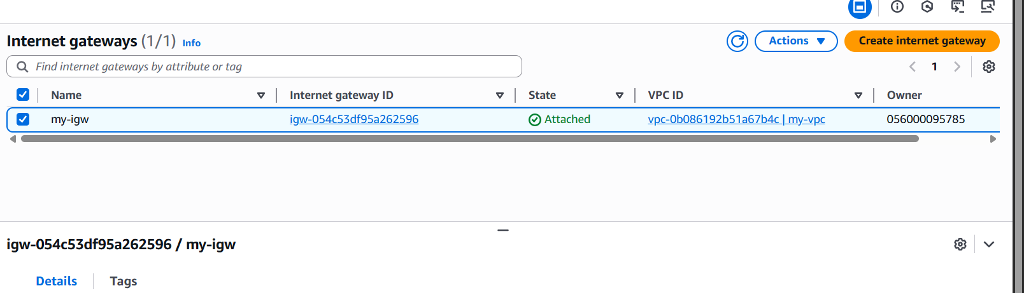
- Create one public route table (RT) and one private route table.
- Go to route tablescreate RTone name public & other privateattach subnet associationattach public subnet to public rtattach private subnet to private RT
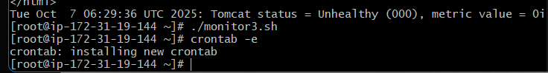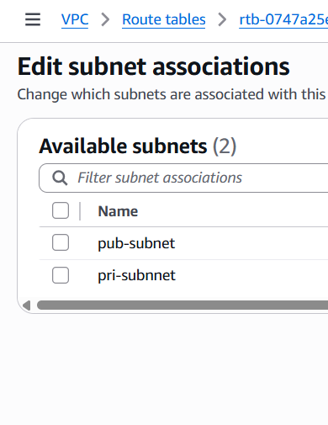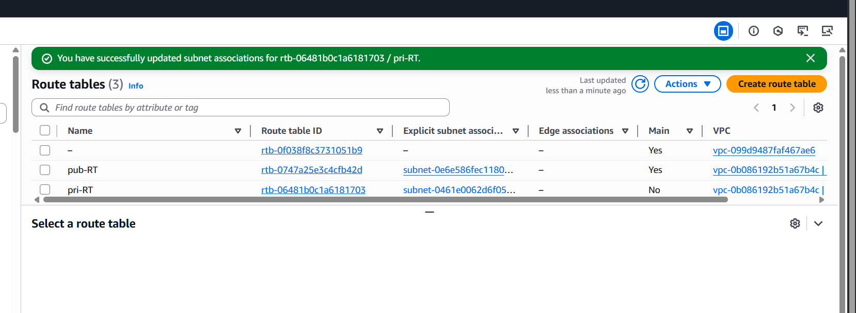
- Deploy a NAT gateway in the public subnet and attach the NAT gateway to the private subnet.
- Go to nat gatewaycreate natgatewayselect vpcselect private subnetallocte elastic ipcreate nat gateway
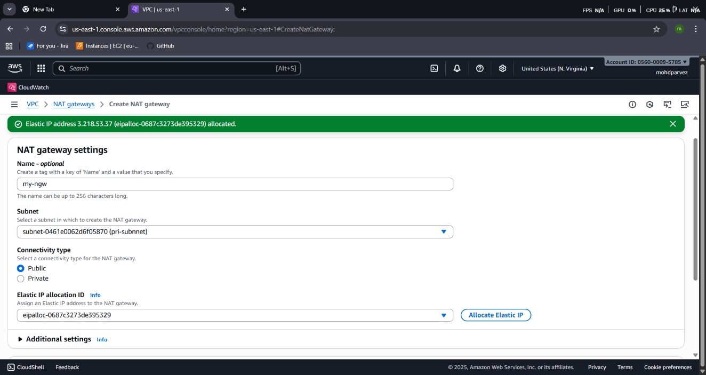
- Go to route tablesedit routesadd routenat gatewaysave
- Nat gateway is attached to the pubRT
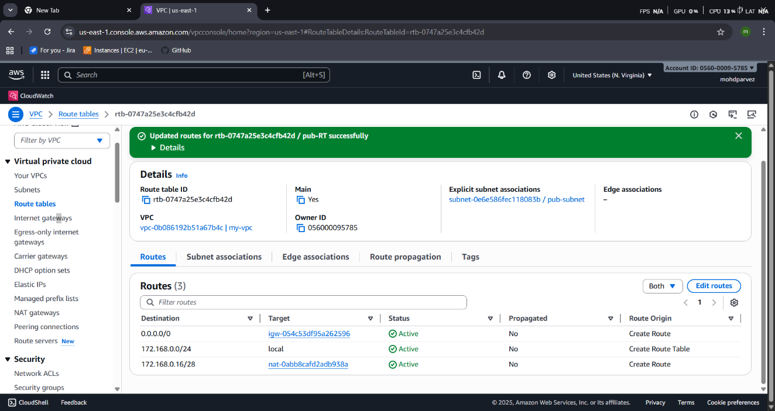
- Create two instances, one in the public subnet and one in the private subnet.
- Go to ec2 launch ec2 select vpc createdselect publicsubnetuse default security groupkeypair create or selectlaunch public instance
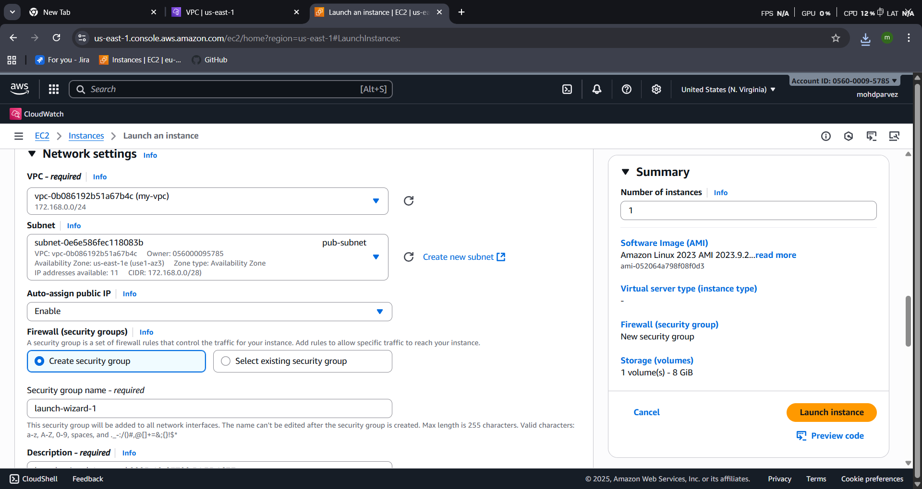
- Go to ec2 launch ec2 select vpc createdselect privatesubnetuse default security groupkeypair create or selectlaunch instance

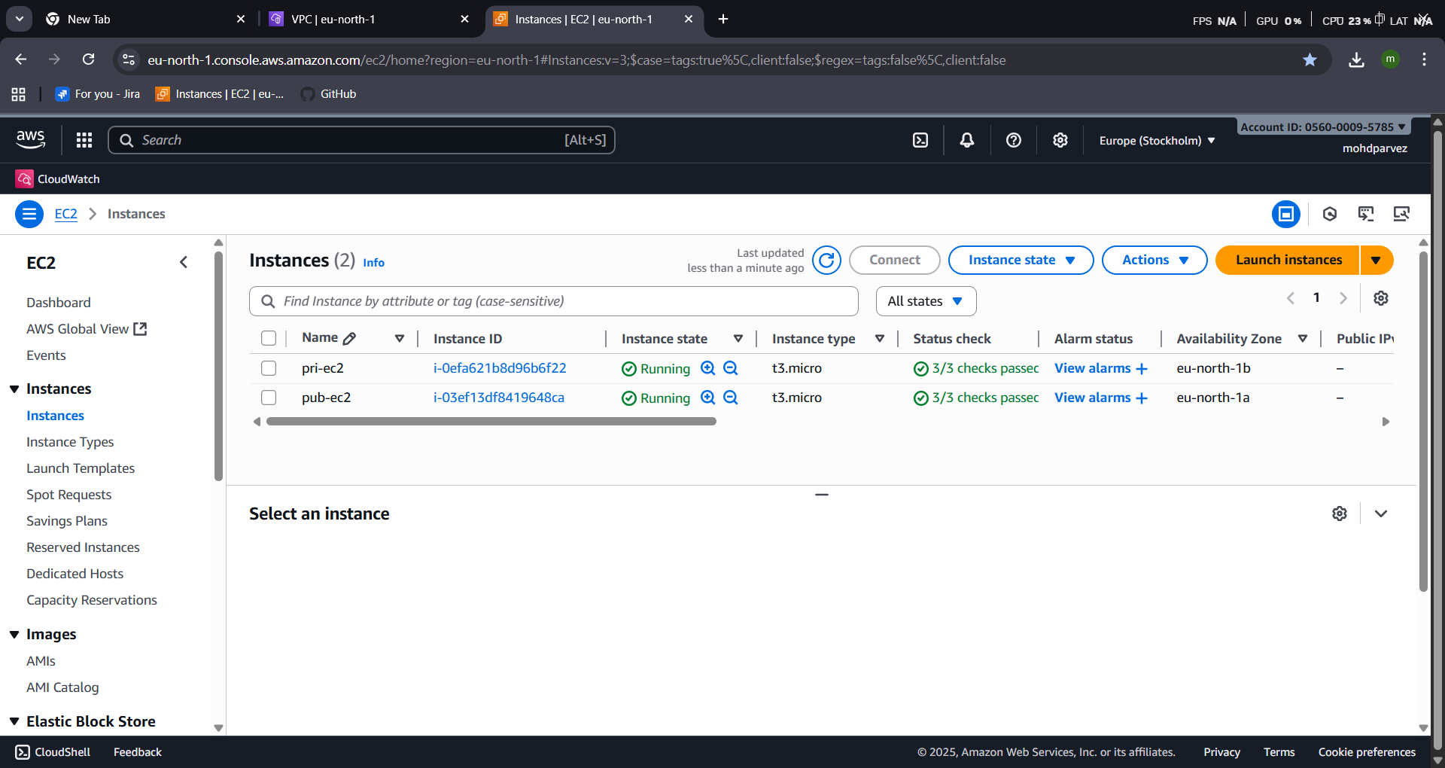
- Deploy Apache server on both EC2 instances with a sample index.html file.
- Connect to the public ec2 instance
- Install httpd(apache application)
- Yum install httpd
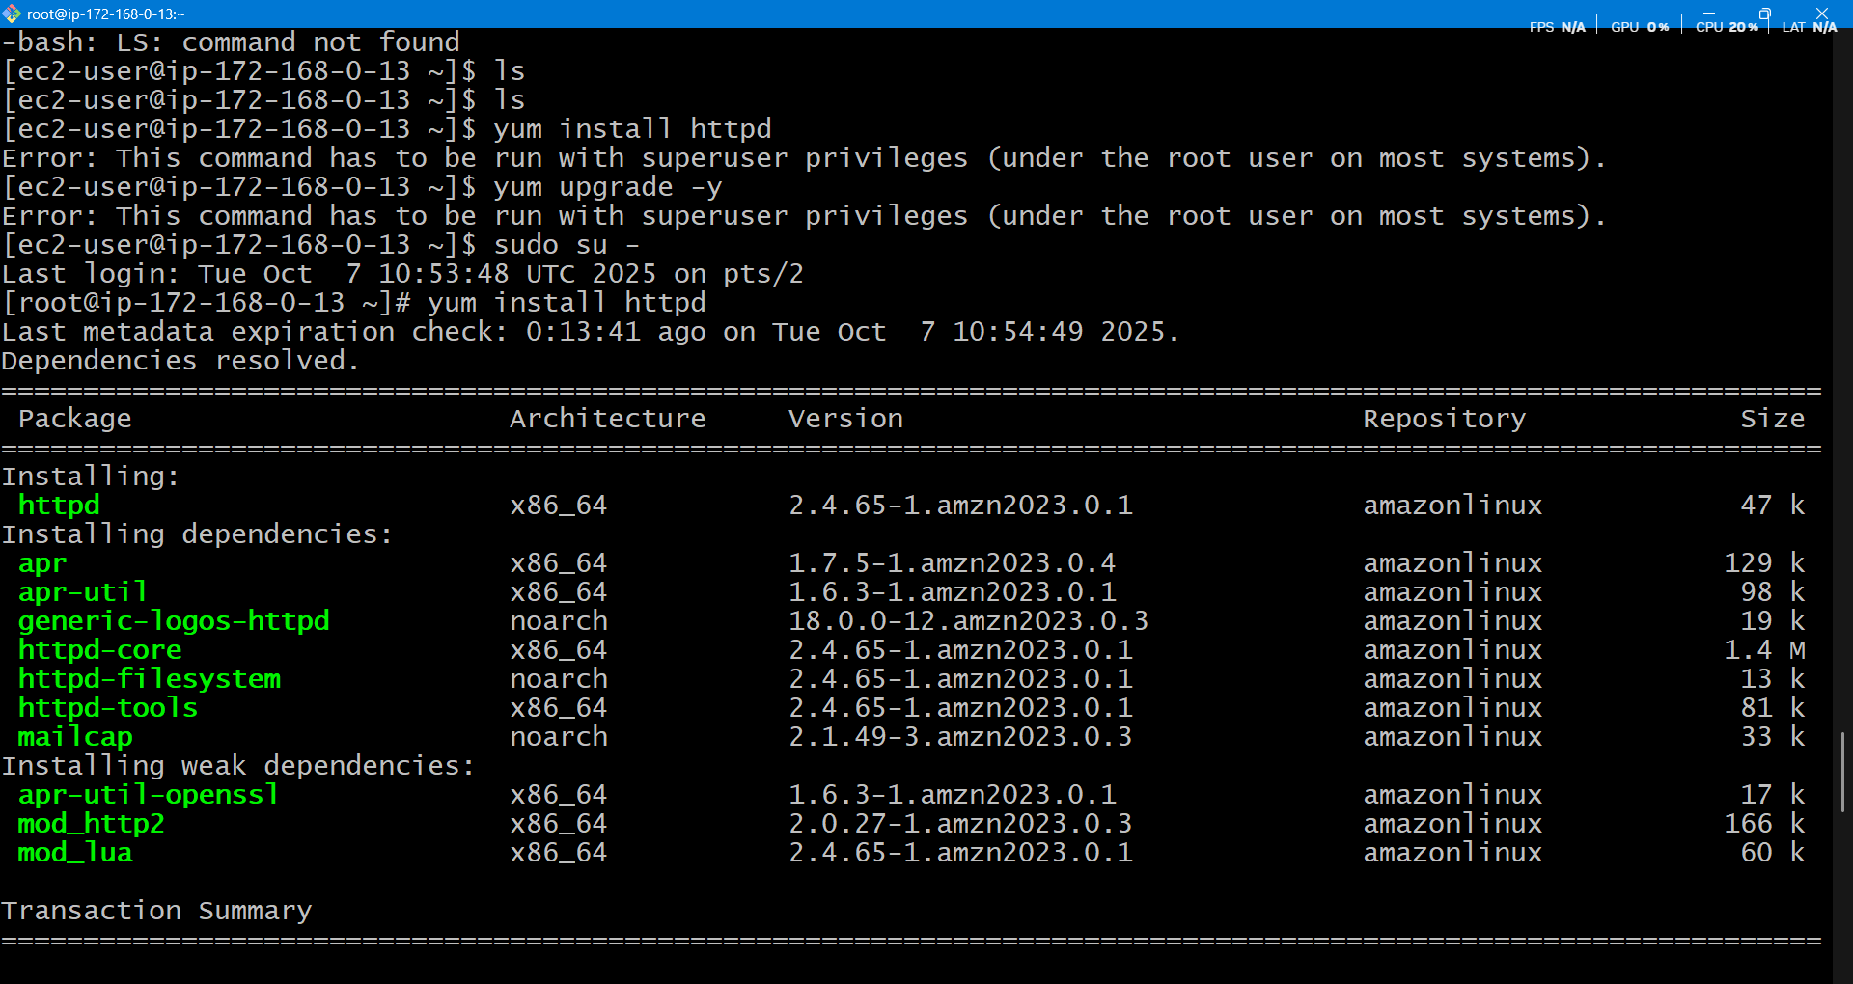
- Systemctl start httpd : start the service
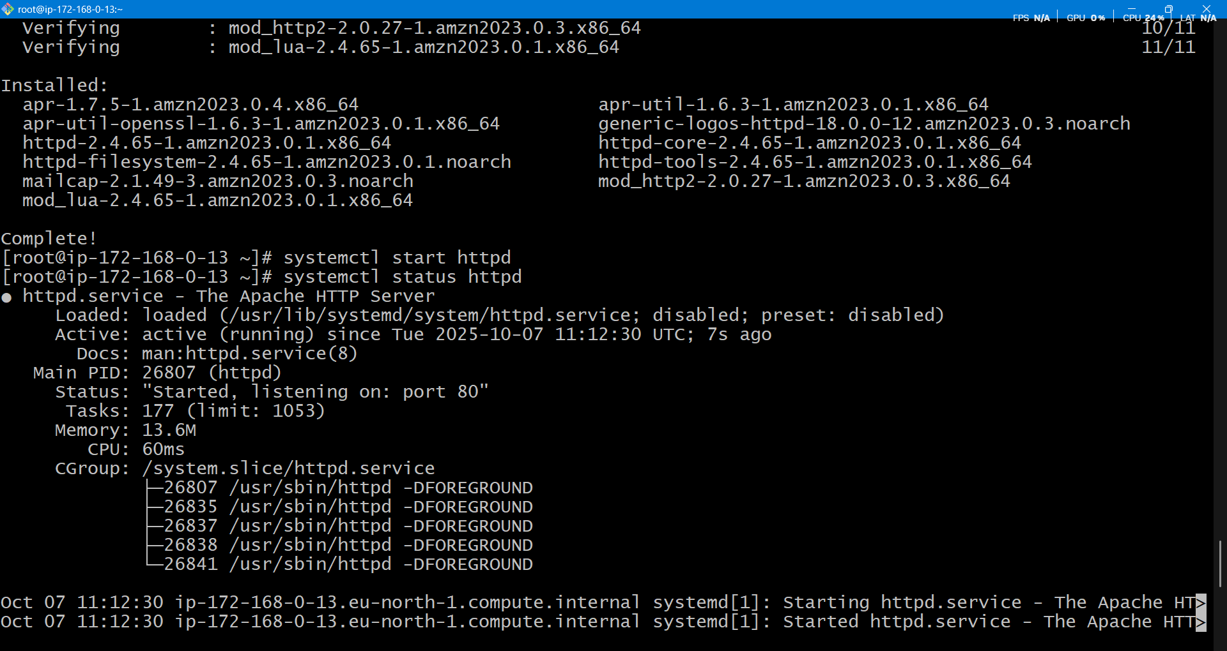
- Deploy the sample index.html go to directory : var/www/html

- Connect to the private ec2
- Copy the pem keycreate file in pub ec2 vi test.pempaste keygive permissionchmod 400 test.pem
- Now connect to private instance use private ip : ssh -i ec2-user@ipv4-private
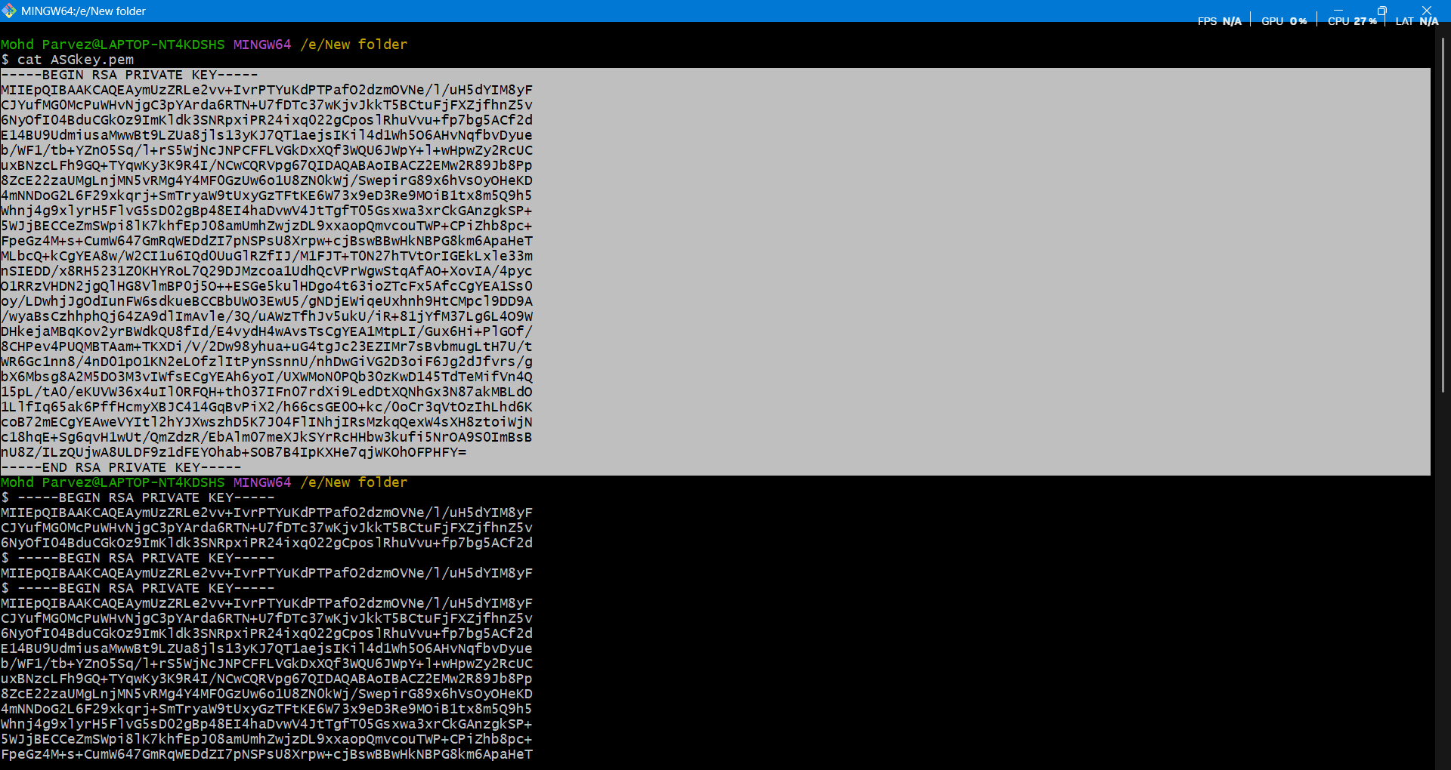
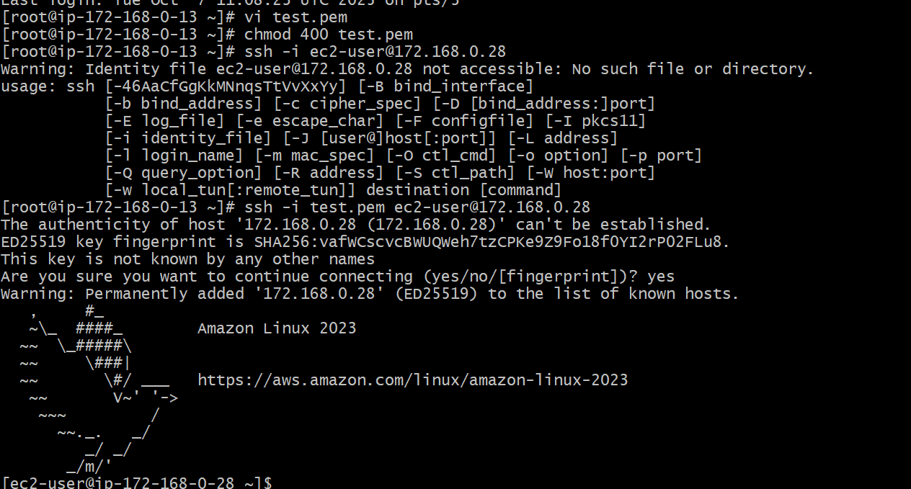

- Create one application load balancer and attach it to both EC2 instances.
- Go to load balancercreate for applicationnameselect vpcselect subnetsselect security groups reviewcreate load balancer
- Attach target groups-create taret group to your instance
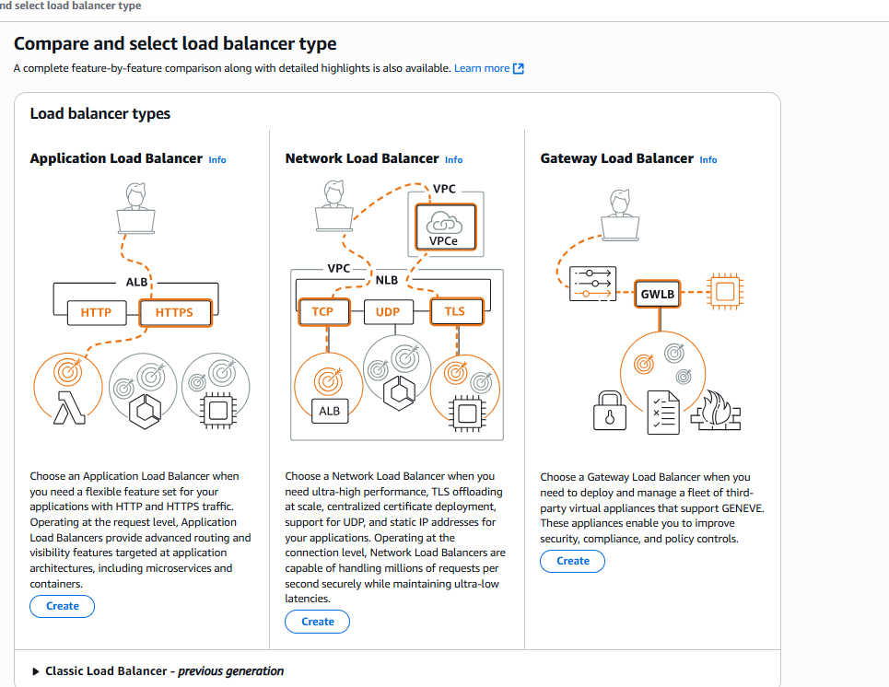
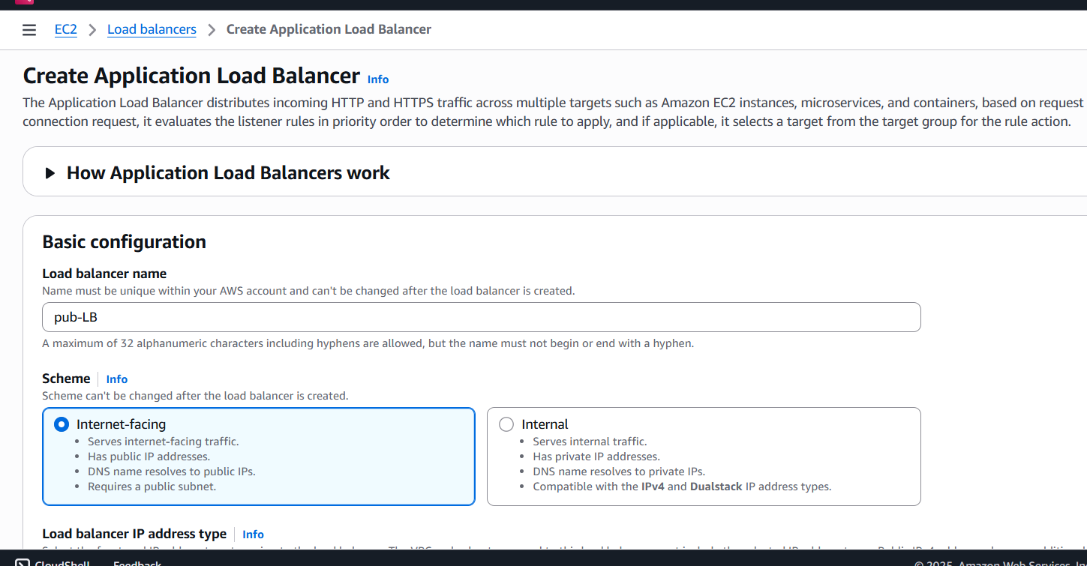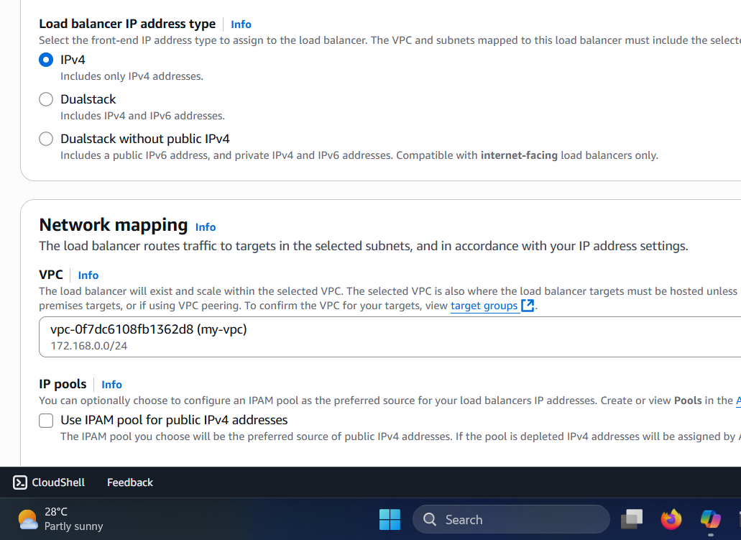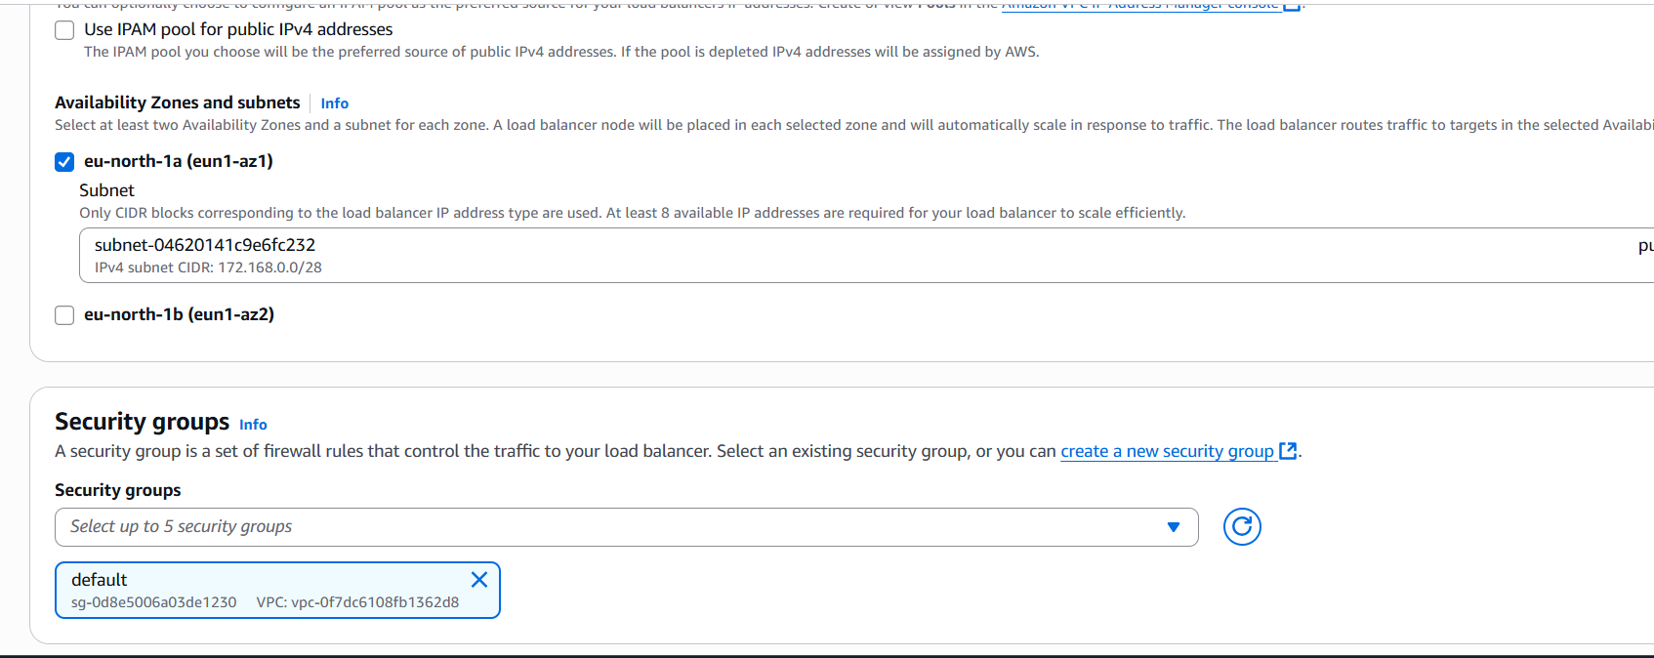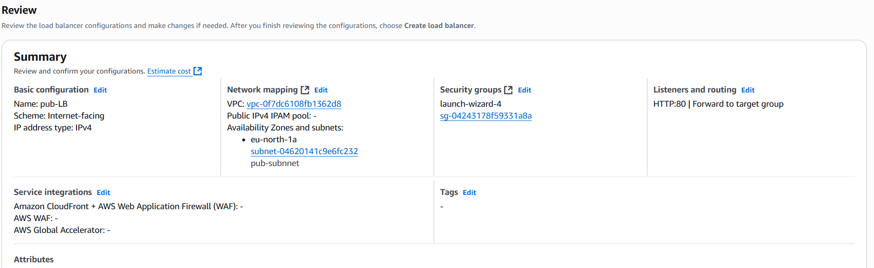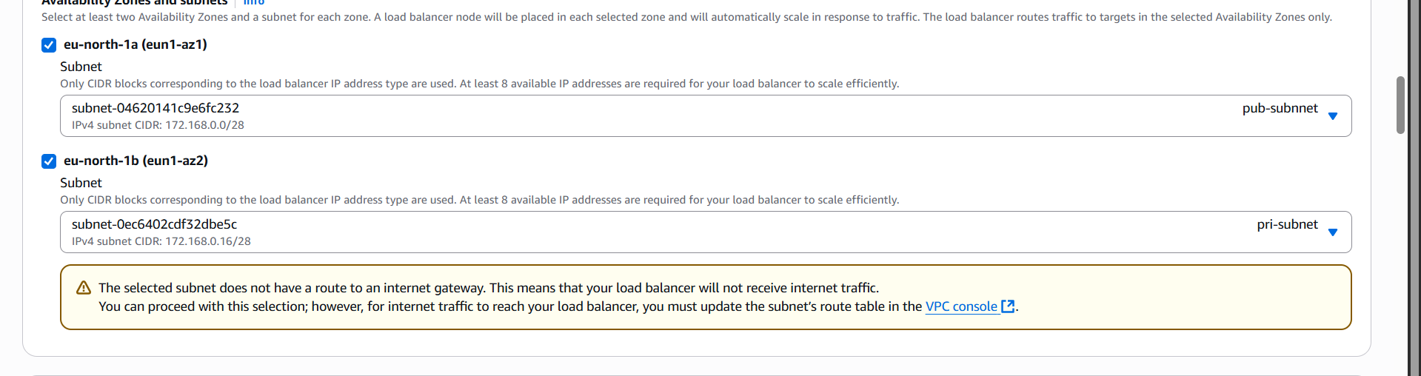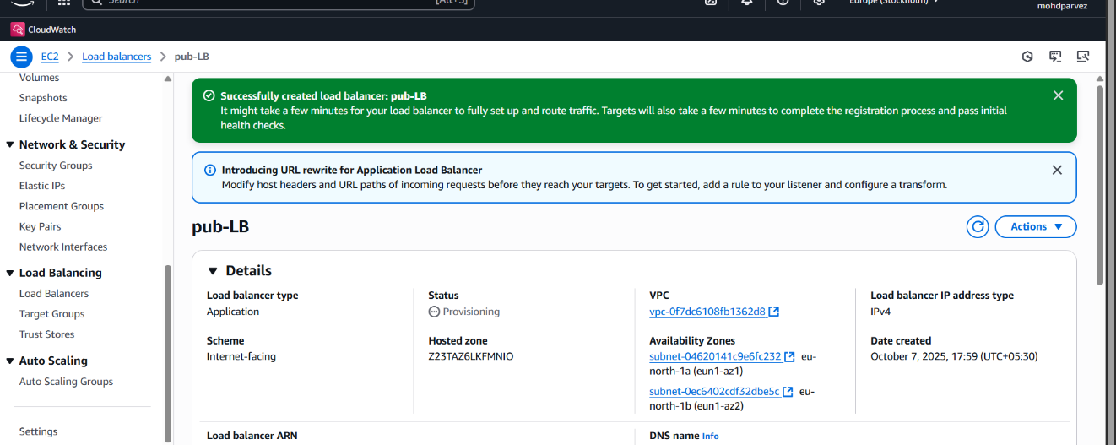
- Store application load balancer logs in S3.

- Store the VPC flow logs in a CloudWatch log group.
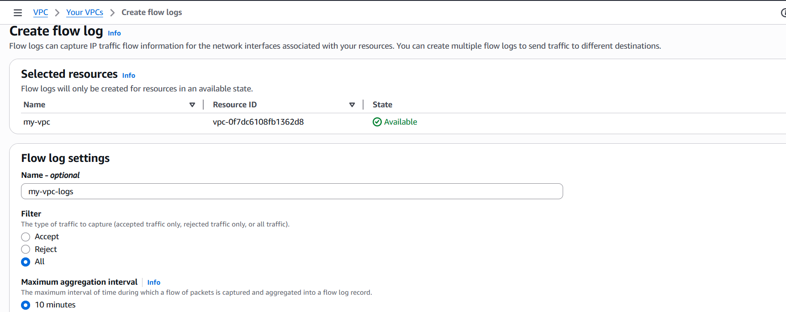

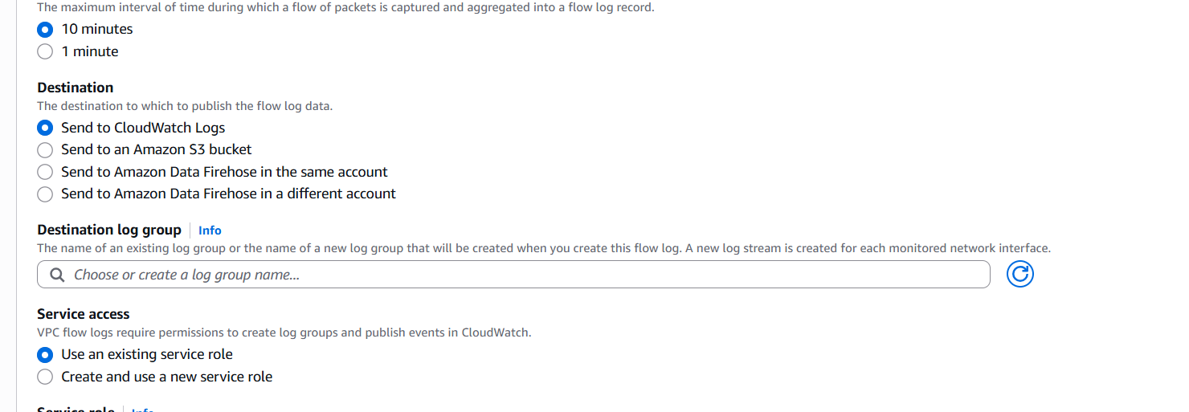

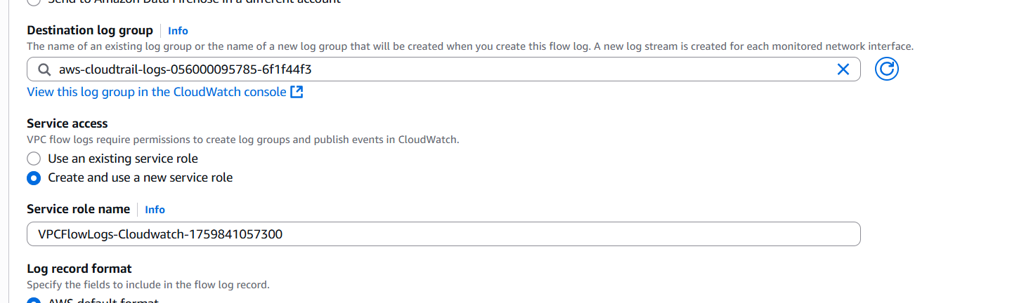
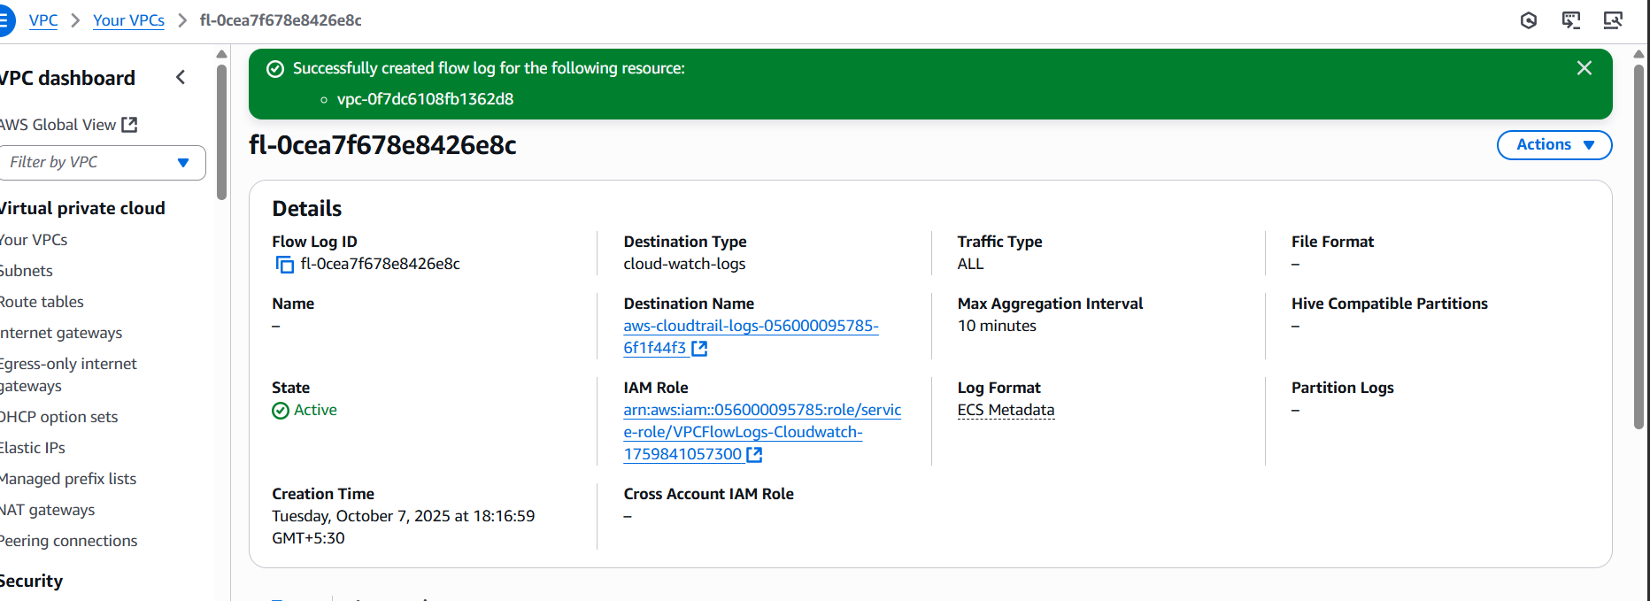
- Create monitoring dashboards to monitor CPU utilization and to monitor the Apache service.
- Go to dashboard create dashboardselect ec2select metric cpu utiliation create widget
- For httpd aws configure in terminal give acess key and secret key
- Write script to monitor the service and push metric to cloud watch

#!/bin/bash

# Configuration
NAMESPACE="Custom/httpdService"
METRIC_NAME="httpdStatus"
DIMENSION_NAME="ServiceName"
DIMENSION_VALUE="httpd"
REGION="eu-north-1" # Change to your AWS region

# Check httpd status
if systemctl is-active --quiet httpd; then
STATUS=1
else
STATUS=0
fi

# Push to CloudWatch
aws cloudwatch put-metric-data \
--metric-name "$METRIC_NAME" \
--namespace "$NAMESPACE" \
--dimensions "$DIMENSION_NAME=$DIMENSION_VALUE" \
--value "$STATUS" \
--region "$REGION"

# Optional: Log locally
echo "$(date): httpd status = $STATUS" >> /var/log/httpd/acess.log
- Create widget add custom metricselect and create the widget
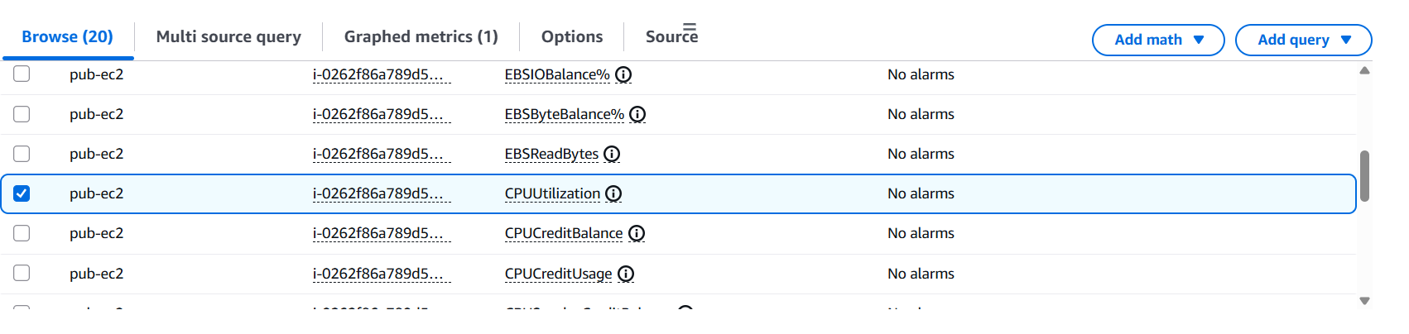

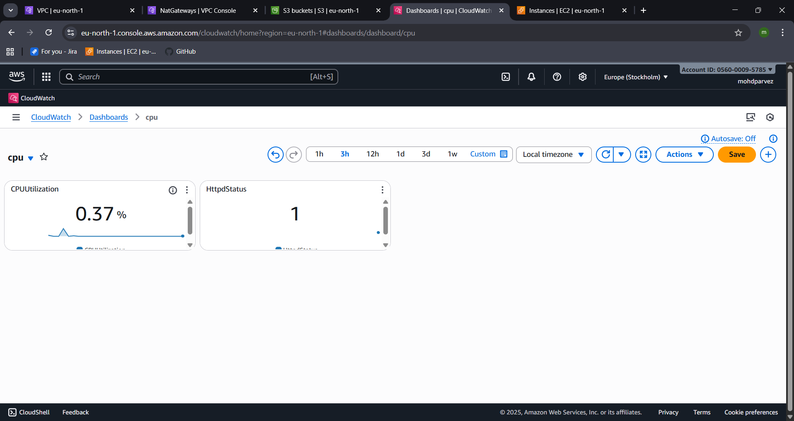

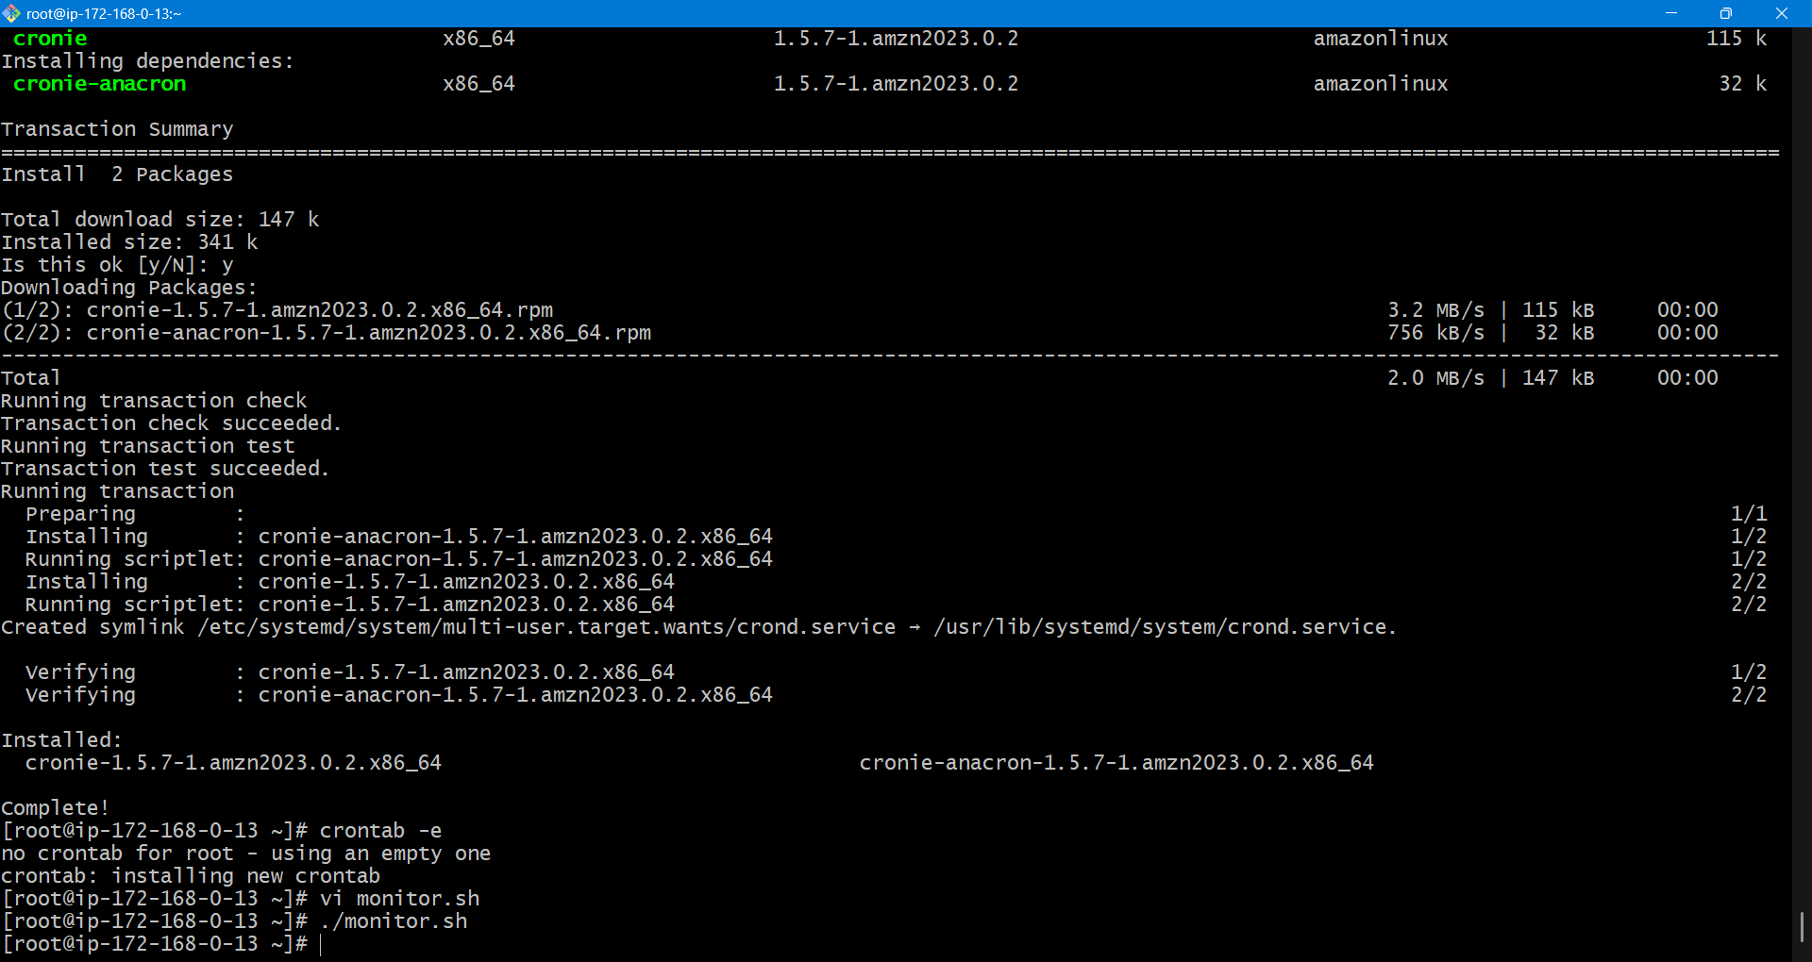
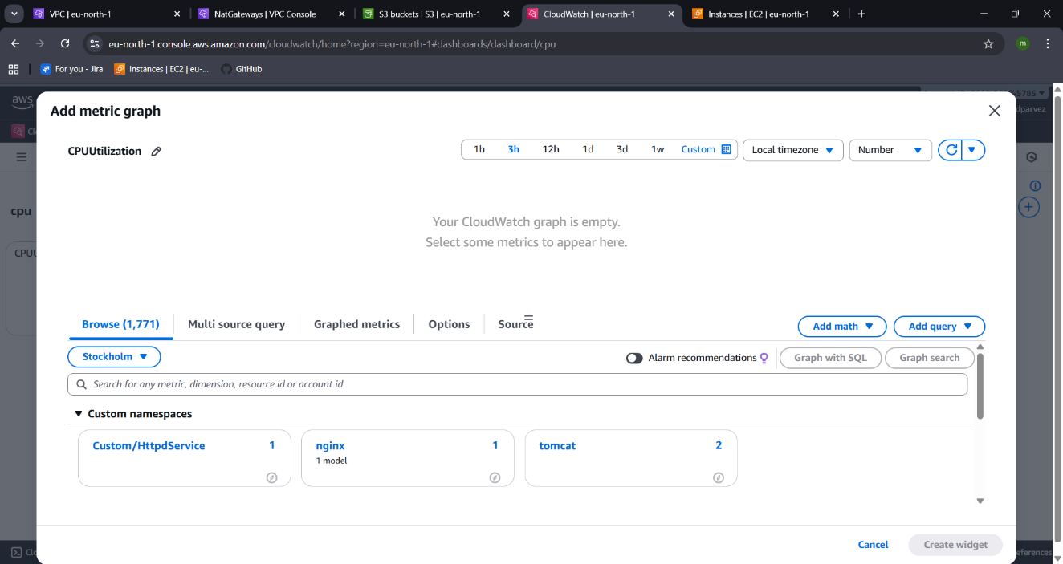
- If CPU utilization is more than 70%, then it should trigger auto scaling and launch new instance.
- For auto scaling you need to create lauch template
- Ec2create lauch templateversionselect amiinstance typekeypairadvance settingnextselect vpcselect zone and subnetattach load balancer to divert the trafficMonitor warmupgroup sizescaling policiesmetric type instance idadd notificationscreate auto scalling
